Assignment 2: Software Implementation

Alia Lootah

College of Interdisciplinary Studies, Zayed University

ICS220 - 22873 Programming Fundamentals

Professor Kuhail

April 15, 2023

**UML Class Diagram and Description:**

**Classes and Attributes:**

1. DentalBranch
   * address (private)
   * phoneNumber (private)
   * manager (private)
2. Staff
   * name (private)
   * id (private)
   * title (private)
3. Manager (inherits from Staff)
4. Receptionist (inherits from Staff)
5. Hygienist (inherits from Staff)
6. Dentist (inherits from Staff)
7. DentalService
   * serviceName (private)
   * serviceCost (private)
8. Patient
   * name (private)
   * id (private)
   * phoneNumber (private)
9. Appointment
   * appointmentID (private)
   * date (private)
   * time (private)
10. Bill
    * billID (private)
    * totalCost (private)
    * VAT (private)

**UML Class Diagram:**

|  |
| --- |
| DentalService |
| -serviceName: str  -serviceCost: float |

|  |
| --- |
| DentalBranch |
| -address: str  -phoneNumber: str  -manager: Manager |
| +add_staff(staff: Staff)  +add_patient(patient: Patient)  +add_service(service: DentalService) |

|  |
| --- |
| Patient |
| -name: str  -id: str  -phoneNumber:str |
| +book_appointment(appointment: Appointment) |

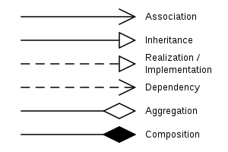

|  |
| --- |
| Manager |

|  |
| --- |
| Staff |
| -name: str  -id: str  -title: str |

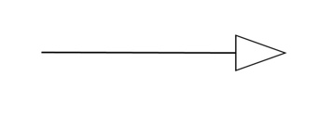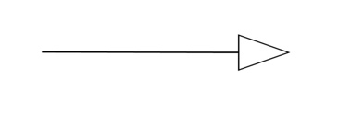

|  |
| --- |
| Hygienist |

|  |
| --- |
| Dentist |

|  |
| --- |
| Receptionist |

|  |
| --- |
| Patient |
| -name: str  -id: str  -phoneNumber:str |
| +book_appointment(appointment: Appointment) |

|  |
| --- |
| Appointment |
| -appointmentID:str  -date: Date  -time: Time  -dentist: Dentist  -services: List[DentalService] |
| +generate_bill(): Bill |

|  |
| --- |
| Bill |
| -billID: str  -totalCost: float  -VAT: float |
| +display_receipt() |